**CSC 325 Adv Data Structures**

**Homework #4**

**Splay Trees**

Name: __Answer Key_______________________ Due: Wed, Apr 24th

1. (2 pts) Given the following splay tree, perform the operation:

* search(64)

Draw the resulting tree after the operation is performed (i.e. after the splay fully completes):

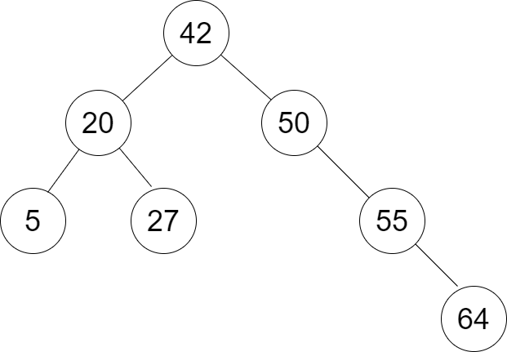

2. (4 pts) Given the following splay tree, perform the operations:

* delete(42)
* search(25)

Draw the resulting tree after all operations are performed (i.e. after all splays fully complete). Assume we splay only on searches.

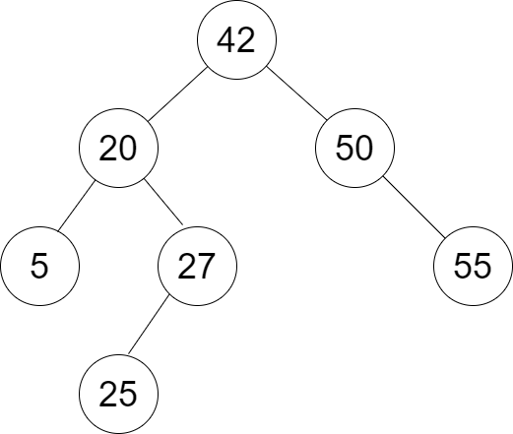

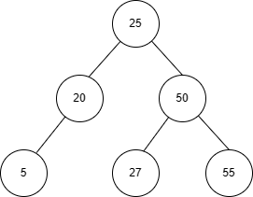

3. (12 pts) Given the following splay tree, perform the operations:

* delete(2)
* delete(5)
* delete(42)
* search(52)
* search(27)
* search(52)

Draw the resulting tree after all operations are performed (i.e. after all splays fully complete). Assume we splay only on searches.

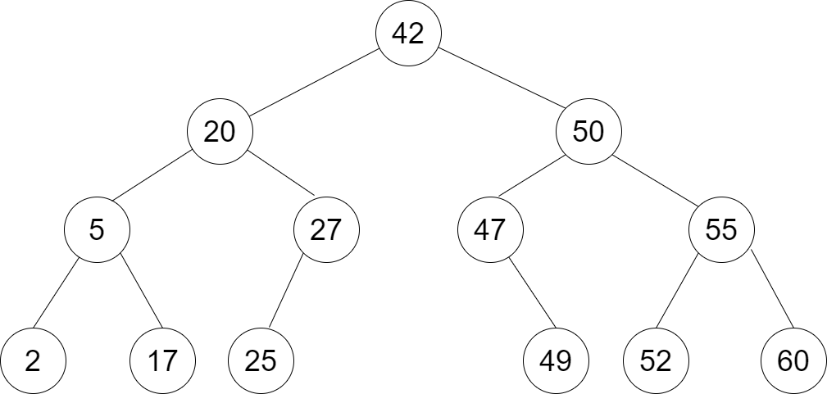

4. (2 pts) Explain which operations a splay tree performs faster than a normal BST in. Also explain why those operations are faster.

The search operation is faster. Search will invoke splay on the searched node. Subsequent searches for the same value will be faster since splay moves the searched node to the root, causing O(1) access.